Name
Tutor
Course
Date
Wearing Mask to Combat COVID-19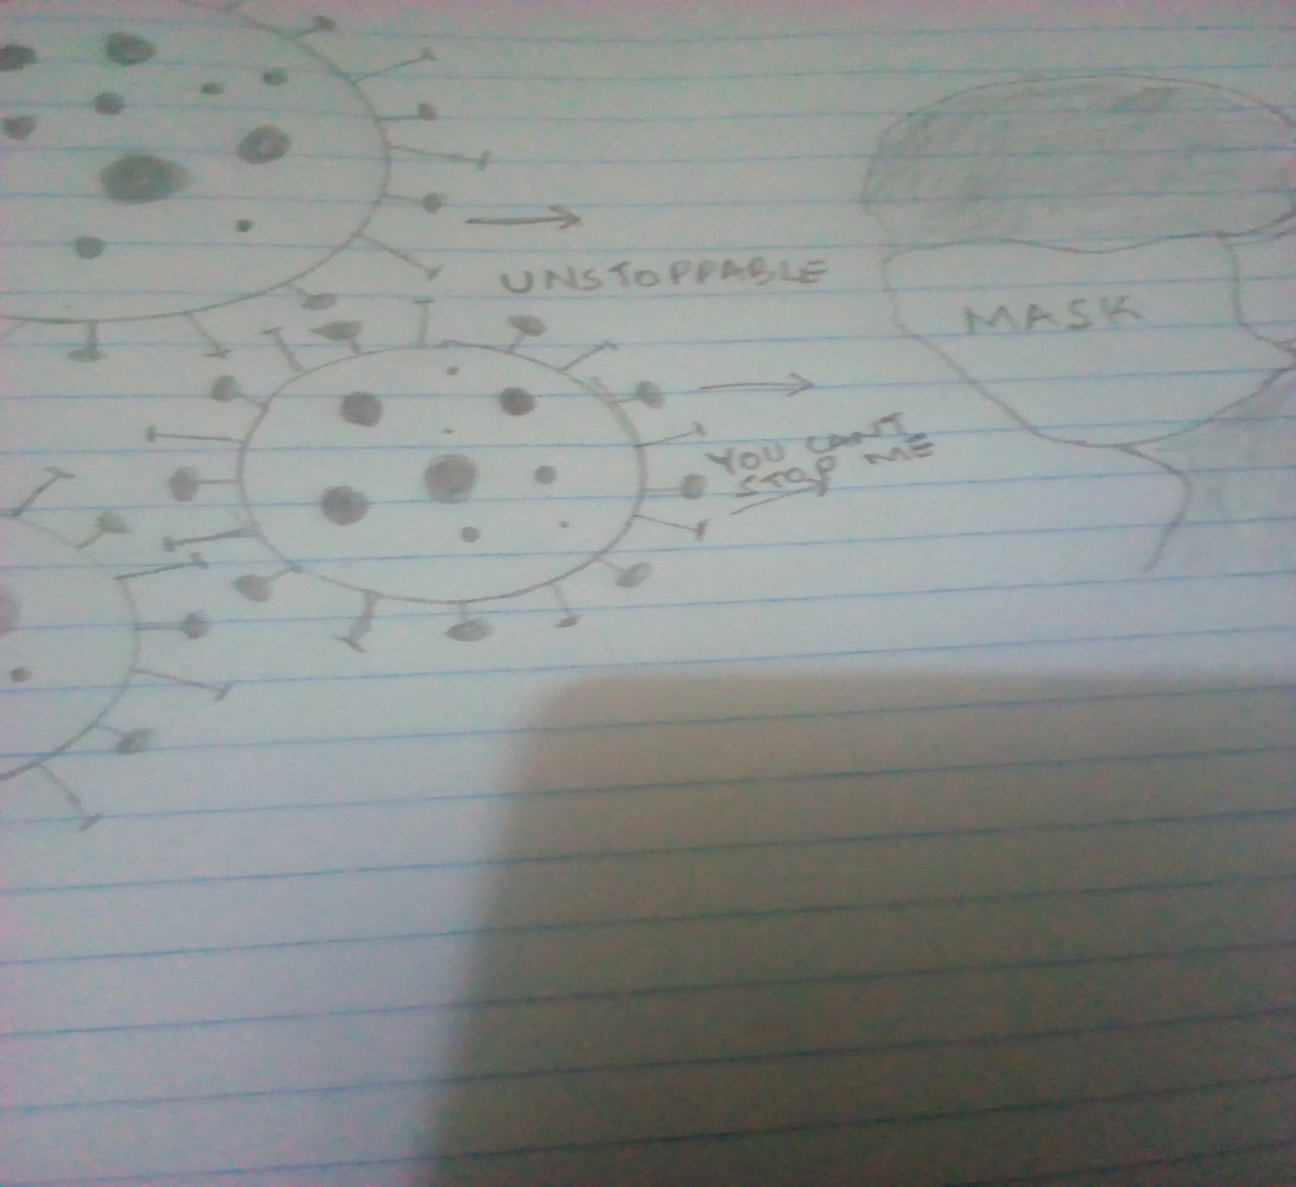MASK CAN’T STOP COVID-19

Memorandum
To:
From:
Date:

Subject: Wearing Mask to Combat COVID-19
With the widespread of COVID-19, wearing face masks has become a norm in many nations. Unfortunately, there is no 100% proof that it can prevent one from being infected. Instead, it may probably protect the public from a potentially infected person who wears the mask rather than the person who wears the mask from a potentially infected public. Yet, wearing a mask in public is important. Filter respirator masks, especially the surgical and non-medical masks, provide little COVID-19 protection for the following reasons:
The virus is in fluid envelopes that surround them can are very small; that one would need an electron microscope to see them. Viruses also do not enter the human body through the mouth and nose only, but also enter through our eyes and even the skin's pores. The only effective barrier that can protect against virus exposure would be a fully encapsulated hazmat suit, which is a standard gear to protect against the viruses usually worn in a virus hazard environment.
Some masks are not only useless in protecting people against COVID-19 but also creates health risks and threats to the wearer. Wearing the masks increases breathing resistance, making it difficult for both inhalation and exhalation. COVID-19 has led to the mask's increased wearing without even being screened of any medical condition first as required. Government regulations are forcing people to wear a mask without considering that some people have pre-existing medical conditions such as breathing difficulties, chest pain, asthma, diabetes, and seizures. It is dangerous to recommend anyone with medical conditions to wear a mask without educating them about the risks involved in wearing them and, even worst, without having been screened and approved by a medical professional first.
Wearing the mask all the time can cause other health conditions such as hypercapnia (Antonio Ivan et al. 369). Hypercapnia is a buildup of carbon dioxide in the bloodstream, and it can affect people who have chronic obstructive pulmonary disease. It is also notable that when there is too much carbon dioxide in the bloodstream, a sudden rise in carbon dioxide in the bloodstream is called acute hypercapnia, which is more dangerous than COVID-19.
In my understanding, wearing a mask can reduce the level of oxygen inhalation and increase the level of inhaling the exhaled carbon dioxide because of wearing a mask. This can cause mild symptoms such as drowsiness, mild headaches, disorientation, shortness of breath, abnormal tiredness or exhausted, and severe hypercapnia symptoms such as irregular heartbeat, hyperventilation, seizures panic attack, and passing out.
The public should be aware that COVID-19 is not airborne. However, it is necessary to wear a mask regularly when you have COVID-19 to prevent infecting others. There is no essence of wearing a mask when someone is alone in their house or car when they are free of covid-19. When in public places or public transport, a mask should be worn, covering only the nose and the mouth. Mask should not be worn when engaging in sports and gym as more oxygen intake is needed. If one must wear a mask, especially due to government regulations, they should wear it to cover their mouth and not their nose. It is also advisable that the masks be designed to be more fitting to allow circulation for air circulation (Cong et al. 531). This allows easy breathing and avoids the inhalation of exhaled carbon dioxide.
Remember that wearing a mask prevents the public from being infected, not preventing you from being infected by the infected public. People are more protected when they practice hygiene. These masks, even when properly sized and fitted, do not protect against the virus. Therefore, it is advisable for the public to focus more on the hygienic measures to prevent the spread of COVID-19.

Works cited
Lazzarino, Antonio Ivan, et al. "Covid-19: Important potential side effects of wearing face masks that we should bear in mind." The BMJ 369 (2020).
Liu, Cong, et al. "Effects of wearing masks on human health and comfort during the COVID-19 pandemic." IOP Conference Series: Earth and Environmental Science. Vol. 531. No. 1. IOP Publishing, 2020.

